# JS Advanced: Exam 15 July 2018

# Problem 4. Online Shop (DOM)

Write a JavaScript program that provides the logic for the given user interface of an online shop’s inventory:

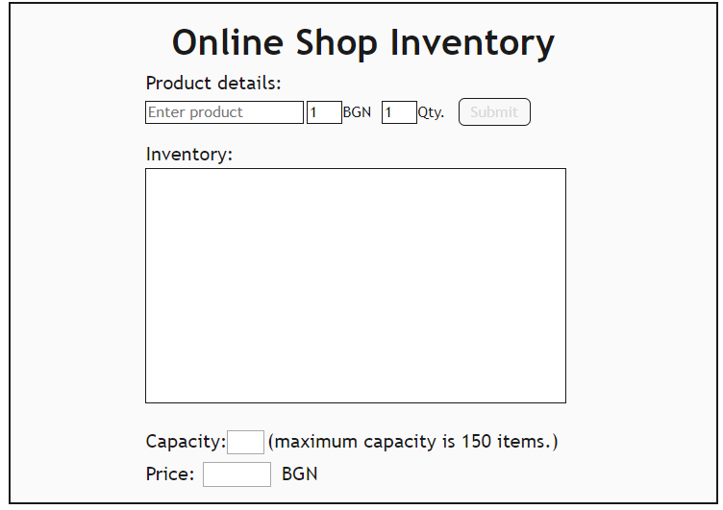

Each order you create should consist of product's **name**, **price** and **quantity**. When the **submit** button is **clicked** the current **product** must be **added** to the inventory and the visualization (**product field, price field, quantity field and submit button**) should be **reset** to the **initial values**. The **submit button** should be **disabled** if the **product field** **is empty**.

Also there is a small **capacity** **field**, which shows how many items are there currently in the inventory. The inventory can store **up to 150 items**. Therefore, you should keep track of its capacity and when **150** items are **reached**, the capacity field should **become red** and it should display **“full”**, also the **submit button, the product field, price field and quantity field** should be **disabled** by adding to them the property “disabled”. In order to change the colour of the capacity field, you should simply **change** its **CSS class** to “fullCapacity”. See the picture below:

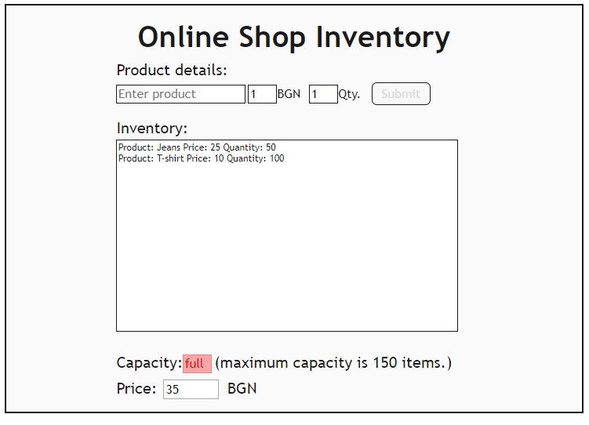

### Output

* You should **only** **submit** the **solution.js file**

Use the following **index.html** and the **solution.js** for the user interface implementation:

|  |
| --- |
| index.html |
| <!DOCTYPE **html**> <**html lang="en"**>  <**head**>  <**meta charset="UTF-8"**>  <**title**>Online Shop</**title**>  <**style**>  .**wrapper** {  **margin**: **auto**;  **width**: 53%;  **border**: 3**px solid rgb**(26, 26, 26);  **background-color**: **rgb**(250, 250, 250);  **padding**: 10**px**;  }   **#header** {  **font-family**: **"Trebuchet MS"**, **Helvetica**, **sans-serif**;  **font-size**: 300%;  **font-weight**: **bold**;  **color**: **rgb**(26, 26, 26);  **text-align**: **center**;  **padding**: 10**px**;  }   **li** {  **list-style-type**: **none**;  }   .**block** {  **display**: **inline-block**;  **margin-left**: 165**px**;  }   .**field** {  **font-family**: **"Trebuchet MS"**, **Helvetica**, **sans-serif**;  **font-size**: 25**px**;  **color**: **rgb**(26, 26, 26);  }   .**custom-select** {  **font-family**: **"Trebuchet MS"**, **Helvetica**, **sans-serif**;  **font-size**: 20**px**;  **background-color**: **rgb**(255, 255, 255);  **color**: **rgb**(26, 26, 26);  **border**: 1**px solid rgb**(26, 26, 26);  **padding**: 2**px**;  **margin-top**: 10**px**;  **width**: 200**px**;  }    .**input1** {  **width**: 40**px**;  **font-family**: **"Trebuchet MS"**, **Helvetica**, **sans-serif**;  **font-size**: 20**px**;  **border**: 1**px solid rgb**(26, 26, 26);  **background-color**: **#ffffff**;  **color**: **rgb**(26, 26, 26);  **padding**: 2**px**;  }   **#capacity** {  **width**: 40**px**;  **font-size**: 20**px**;  **padding**: 2**px**;  **font-family**: **"Trebuchet MS"**, **Helvetica**, **sans-serif**;  }   **#sum** {  **width**: 80**px**;  **font-size**: 20**px**;  **padding**: 2**px**;  **font-family**: **"Trebuchet MS"**, **Helvetica**, **sans-serif**;  **margin**: 10**px** 10**px**;  }   .**fullCapacity** {  **width**: 40**px**;  **font-size**: 20**px**;  **padding**: 2**px**;  **font-family**: **"Trebuchet MS"**, **Helvetica**, **sans-serif**;  **color**: **rgb**(250, 0, 0);  **border**: 1**px solid #f07777b2**;  **background-color**: **#f78989bb**;  }   .**display** {  **font-family**: **"Trebuchet MS"**, **Helvetica**, **sans-serif**;  **font-size**: 15**px**;  **border**: 1**px solid rgb**(26, 26, 26);  **padding**: 2**px**;  **background-color**: **#ffffff**;  **color**: **rgb**(26, 26, 26);  **margin-top**: 5**px**;  **width**: 100%;  **height**: 300**px**;  }   .**text** {  **font-family**: **"Trebuchet MS"**, **Helvetica**, **sans-serif**;  **font-size**: 20**px**;  **color**: **rgb**(26, 26, 26);  **margin-right**: 10**px**;  }   .**button**:**enabled** {  **font-family**: **"Trebuchet MS"**, **Helvetica**, **sans-serif**;  **font-size**: 20**px**;  **cursor**: **pointer**;  **border**: 1**px solid rgb**(26, 26, 26);  **padding**: 5**px** 15**px**;  **margin**: 3**px**;  **border-radius**: 8**px**;  }   .**button**:**disabled** {  **background**: **rgb**(248, 248, 248);  **cursor**: **pointer**;  **color**: **rgb**(216, 216, 216);  **font-size**: 20**px**;  **padding**: 5**px** 15**px**;  **font-family**: **"Trebuchet MS"**, **Helvetica**, **sans-serif**;  **margin**: 3**px**;  **border**: 1**px solid rgb**(26, 26, 26);  **border-radius**: 8**px**;  }  </**style**>  <**script src="https://code.jquery.com/jquery-3.1.1.min.js"**></**script**>  </**head**>  <**body**> <**div class="wrapper"**> </**div**> <**script src="solution.js"**></**script**> <**script**>*onlineShop*(**'.wrapper'**)</**script**> </**body**> |

|  |
| --- |
| solution.js |
| **function** *onlineShop*(selector) {  **let** form = **`<div id="header">Online Shop Inventory</div>  <div class="block">  <label class="field">Product details:</label>  <br>  <input placeholder="Enter product" class="custom-select">  <input class="input1" id="price" type="number" min="1" max="999999" value="1"><label class="text">BGN</label>  <input class="input1" id="quantity" type="number" min="1" value="1"><label class="text">Qty.</label>  <button id="submit" class="button" disabled>Submit</button>  <br><br>  <label class="field">Inventory:</label>  <br>  <ul class="display">  </ul>  <br>  <label class="field">Capacity:</label><input id="capacity" readonly>  <label class="field">(maximum capacity is 150 items.)</label>  <br>  <label class="field">Price:</label><input id="sum" readonly>  <label class="field">BGN</label>  </div>`**;  $(selector).html(form);  ***// Write your code here*** } |